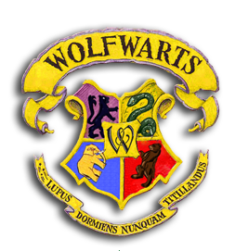

Wolfwarts School of Witchcraft and Wizardry
Headmaster: Akelus Grumblemore
(Order of Powell, First Class, Grand Poohb., Chief Warlock,
Supreme Grumpy, International Confed. of Wizards)
Dear Cub,
We are pleased to inform you that you have now accepted into the Wolfwarts School of Witchcraft and Wizardry! Schooling takes only one weekend, and will take place from the 11th to the 13th of November. We will be staying on the train while the school rooms are closed for renovations.
Yours sincerely,
Flitinera Rakshonnagal

Location: Joseph Harris Scout Park, Hearn Rd, Mt Martha
About it: We will be staying in the Railway Carriages – three ‘red rattler’ train carriages and adjoining undercover ‘station platforms’. Accommodation is in multiple shared rooms – boys and girls separate. Also, Kitchen, dining car, recreation, toilet and shower facilities. The Scout Park is in a bush setting with plenty of onsite activities for our Wizards & Witches to undertake!
Transport: We will be organising carpooling – parents willing to provide transport, please advise.
Cost: $80 – includes accommodation, food and activity equipment
Leaders: Our Leaders will be attending, plus we’re looking for volunteer parents for
Cooking and, depending on Cub numbers, supervision (please respond ASAP – Working with Children required).
Depart: Meet at the Scout Hall at 6pm, Fri 11th Nov. - Ready for a 6:30pm departure.
Return: 1:45 pm Sunday, 13th Nov – depart from Mt Martha
3:15-3:30 pm arrive back at Scout Hall.
Take: Kit list is available on the paperwork/downloads page of our website (dormitory accommodation list – dilly bag not required). NOTE: All our Witches and Wizards are encouraged to bring along an appropriate costume. ALSO, very old clothes for the Duelling (flour fight) and, depending on weather, we may get to do the obstacle course – clothes will get lovely and dirty AND large plastic bags for safe return of the clothes home!
NO: Phones, MP3 players, electronic games, radios or similar may NOT be taken.

To allow planning....

Please reply, via email, ASAP re attendance, any parent volunteering and any dietary requirements.


Full payment of $80 per Cub, and the form below are required by Tuesday 8th November.

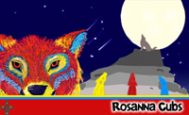
Regards
The Leaders
Rosanna Cub Scouts See us at http://www.rosannacubs.org

Permission Form - Rosanna Cub Scouts

I, ______________________________________ give my permission and attach $80 payment per Cub

for ___________________________________ to attend the 2016 Pack Holiday at Bay Park, Mt Martha, 11-13 Nov.

Special Dietary Requirements (for catering purposes)

______________________________________________________________________________

I understand that transport to and from the camp will be by car
Signature of parent or guardian ______________________________

